**Bayer Low Tunnel Volatility Study**

Summary of 20-ARL-SB22 study

*Rodrigo Werle1, Ryan DeWerff 2, Nick Arneson3, Sarah Striegel 4, Nikola Arsenijevic5, Felipe Faleco5, Kolby Grint5, Haleigh Ortmeier-Clarke5, Jose Nunes6 and Emily Glaeser 7*

*1 Principal Investigator, 2 Research Technician, 3 Outreach Research and Extension Associate, 4 Former Graduate Student, 5 Graduate Student, 6 Visiting Scholar,*

*7 Undergraduate Research Assistant*

Questions on the contents of this report should be directed to Rodrigo Werle (rwerle@wisc.edu) and Sarah Striegel (sstriegel@wisc.edu).

**

**Contents**

Methods...................................................................................................................................... 5

Results......................................................................................................................................... 7

**List of Figures**

Figure 1. XtendiMax with VaporGrip + Roundup PowerMax at 28 DAT.................... 12

Figure 2. XtendiMax with VaporGrip + Roundup PowerMax + 2% MON 51817 –

VaporGrip at 28 DAT............................................................................................................ 13

Figure 3. XtendiMax with VaporGrip + Roundup PowerMax + 4% MON 51817 –

VaporGrip at 28 DAT........................................................................................................... 14

Figure 4. XtendiMax with VaporGrip + Roundup PowerMax + Liberty 280 SL at

28 DAT..................................................................................................................................... 15

Figure 5. XtendiMax with VaporGrip + Roundup PowerMax + Liberty 280 SL + 2%

MON 51817 – VaporGrip at 28 DAT.................................................................................. 16

Figure 6. XtendiMax with VaporGrip + Roundup PowerMax + Liberty 280 SL + 4%

MON 51817 – VaporGrip at 28 DAT.................................................................................. 17

Figure 7. MON 301286 – RupXtend II VGrip at 28 DAT............................................... 18

Figure 8. MON 301286 – RupXtend II VGrip + 2% MON 51817 - VaporGrip at 28

DAT.......................................................................................................................................... 19

Figure 9. MON 301286 – RupXtend II VGrip + 4% MON 51817 – VaporGrip at 28

DAT.......................................................................................................................................... 21

Figure 10. MON 301286 – RupXtend II VGrip + Liberty 280 SL at 28 DAT............. 22

Figure 11. MON 301286 – RupXtend II VGrip + Liberty 280 SL + 2% MON 51817

– VaporGrip at 28 DAT........................................................................................................ 23

Figure 12. MON 301286 – RupXtend II VGrip + Liberty 280 SL + 4% MON 51817

– VaporGrip at 28 DAT........................................................................................................ 24

Figure 13. Nontreated Check at 28 DAT............................................................................. 25

**List of Tables**

Table 1. Weather conditions in the 48 h period of flat placement under the low tunnels at the University of Wisconsin-Madison Arlington Agriculture Research

Station........................................................................................................................................ 6

Table 2. Sum of soybean stand count, sum of injured plants and the % of injured soybean plants 14 and 28 days after treatment in the three replications within 25 ft quadrant at the University of Wisconsin-Madison Arlington Agriculture Research

Station....................................................................................................................................... 11

**Methods**

* Soybean variety: CZ 1549GTLL
* Soybean seeding rate: 140,000 seeds ac-1 at 1.5” depth
* Soybean row width: 30” row width
* Soybean planting date: June 8
* Plot maintenance:
* PRE herbicide treatment – June 8, 2 pts ac-1 Prefix
* POST herbicide treatment – July 1, 22 fl oz ac-1 Roundup PowerMax + 8.5 lbs AMS/100 gal
* Herbicide treatment (flats): 9:00 to 10:05 am July 8
* Soybean stage at flat application: V4
* Flat removal from low-tunnel: 8:30 to 10:05 am July 10
* Results presented at 14 and 28 days after treatment (DAT) for the 25-ft quadrant with the most severe and consistent injury
* Photos taken at 28 DAT

Table 1. Weather conditions in the 48 h period of flat placement under the low tunnels at the University of Wisconsin-Madison Arlington Agriculture Research Station.

|  |  |  |  |  |  |  |  |  |  |  |  |  |  |  |  |  |
| --- | --- | --- | --- | --- | --- | --- | --- | --- | --- | --- | --- | --- | --- | --- | --- | --- |
| Date | Soil flat temp (F) | | | Air temp (6 in, F) | | | Air temp (27 in, F) | | | Relative humidity (%) | | | Air temp (39 in, F) | | | Rainfall (in) |
| Avg | Max | Min | Avg | Max | Min | Avg | Max | Min | Avg | Max | Min | Avg | Max | Min |
| 0-24 h | 84.7 | 106.4 | 69.3 | 80.1 | 93.5 | 68.1 | 79.9 | 92.5 | 68.2 | 80.8 | 96.4 | 61.0 | 78.8 | 89.8 | 67.8 | 0.0 |
| 24-48 h | 76.7 | 103.1 | 66.1 | 74.5 | 96.5 | 65.6 | 74.2 | 96.6 | 65.8 | 89.8 | 98.5 | 66.8 | 71.7 | 88.4 | 65.0 | 3.0 |

**Results**

 Source: University of Wisconsin-Madison Cropping Systems Weed Science, 2020

 Source: University of Wisconsin-Madison Cropping Systems Weed Science, 2020

 Source: University of Wisconsin-Madison Cropping Systems Weed Science, 2020

Table 2. Sum of soybean stand count, sum of injured plants and the % of injured soybean plants 14 and 28 days after treatment in the three replications within 25 ft quadrant at the University of Wisconsin-Madison Arlington Agriculture Research Station.

|  |  |  |  |  |  |
| --- | --- | --- | --- | --- | --- |
| Treatment | Stand count | Injured plants | | %, Injured plants | |
| 14 | 28 | 14 | 28 |
| XtendiMax with VaporGrip + Roundup PowerMax | 143 | 45 | 54 | 32.5 | 40.3 |
| XtendiMax with VaporGrip + Roundup PowerMax + 2% MON 51817 - VaporGrip | 164 | 0 | 0 | 0.0 | 0.0 |
| XtendiMax with VaporGrip + Roundup PowerMax + 4% MON 51817 - VaporGrip | 161 | 9 | 10 | 5.4 | 6.5 |
| XtendiMax with VaporGrip + Roundup PowerMax + Liberty 280 SL | 152 | 80 | 81 | 52.5 | 53.1 |
| XtendiMax with VaporGrip + Roundup PowerMax + Liberty 280 SL + 2% MON 51817 - VaporGrip | 159 | 4 | 7 | 2.7 | 4.4 |
| XtendiMax with VaporGrip + Roundup PowerMax + Liberty 280 SL + 4% MON 51817 - VaporGrip | 154 | 6 | 6 | 4.0 | 3.8 |
| MON 301286 – RupXtend II VGrip | 142 | 69 | 72 | 48.6 | 50.3 |
| MON 301286 – RupXtend II VGrip + 2% MON 51817 - VaporGrip | 155 | 9 | 14 | 5.6 | 8.5 |
| MON 301286 – RupXtend II VGrip + 4% MON 51817 - VaporGrip | 153 | 6 | 7 | 4.1 | 4.8 |
| MON 301286 – RupXtend II VGrip + Liberty 280 SL | 150 | 81 | 80 | 53.3 | 53.3 |
| MON 301286 – RupXtend II VGrip + Liberty 280 SL + 2% MON 51817 - VaporGrip | 153 | 43 | 42 | 28.4 | 27.3 |
| MON 301286 – RupXtend II VGrip + Liberty 280 SL + 4% MON 51817 - VaporGrip | 155 | 11 | 11 | 6.8 | 7.1 |
| Nontreated Check | 154 | 0 | 0 | 0.0 | 0.0 |

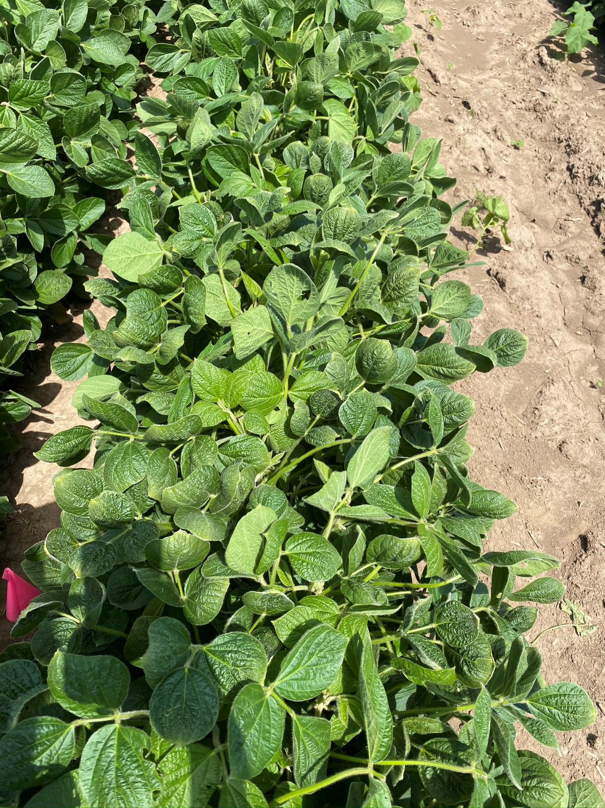

Figure 1. XtendiMax with VaporGrip + Roundup PowerMax at 28 DAT.

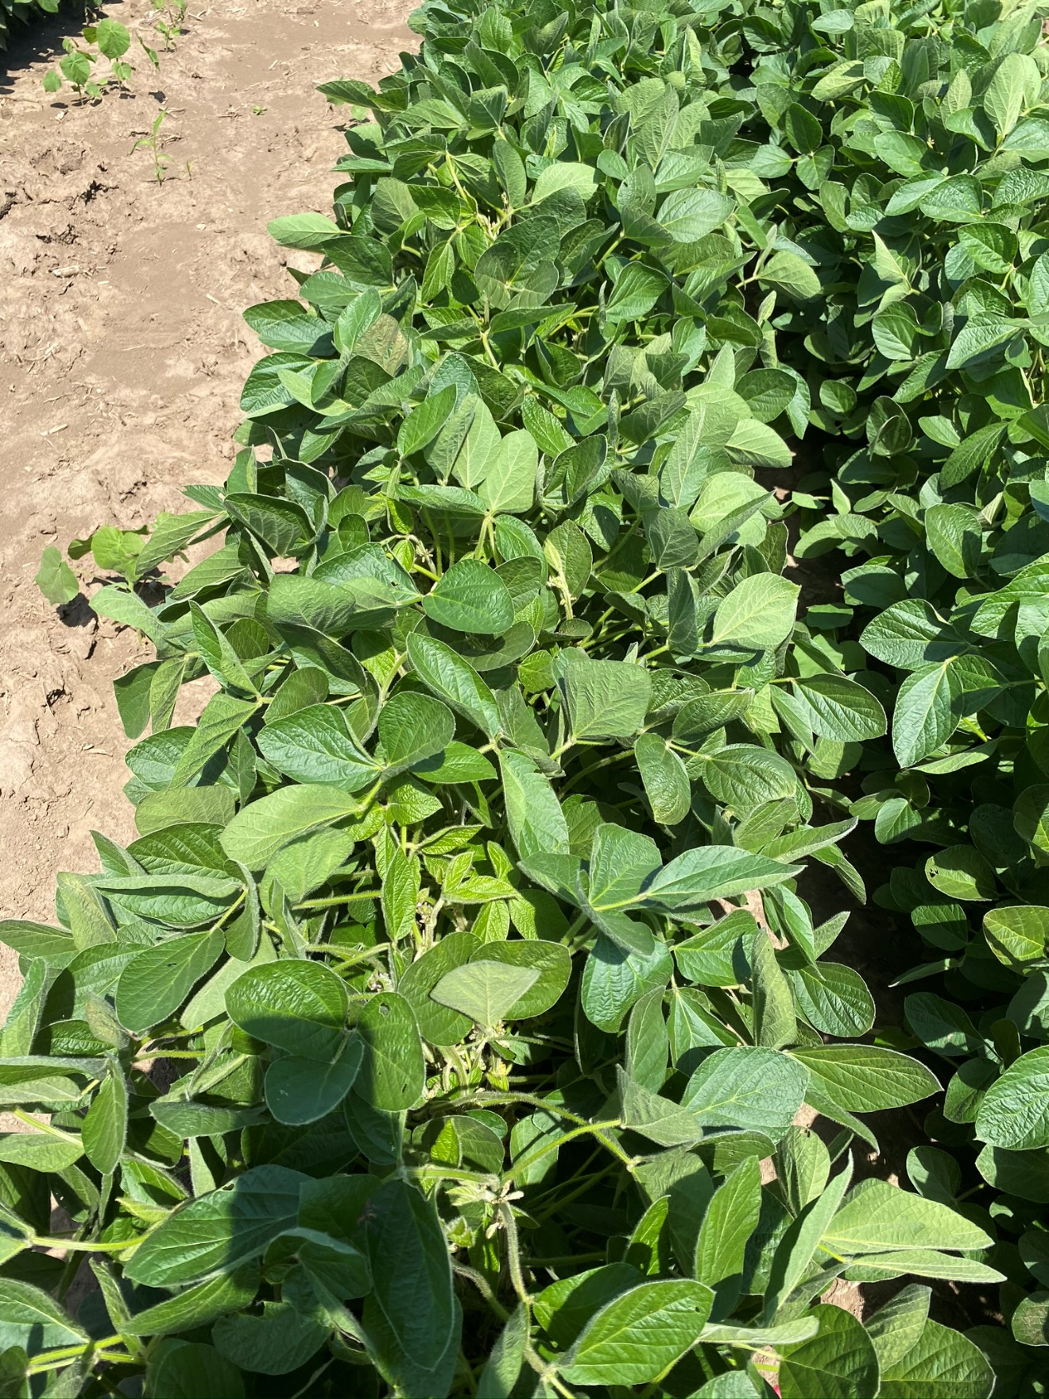

Figure 2. XtendiMax with VaporGrip + Roundup PowerMax + 2% MON 51817 – VaporGrip at 28 DAT.

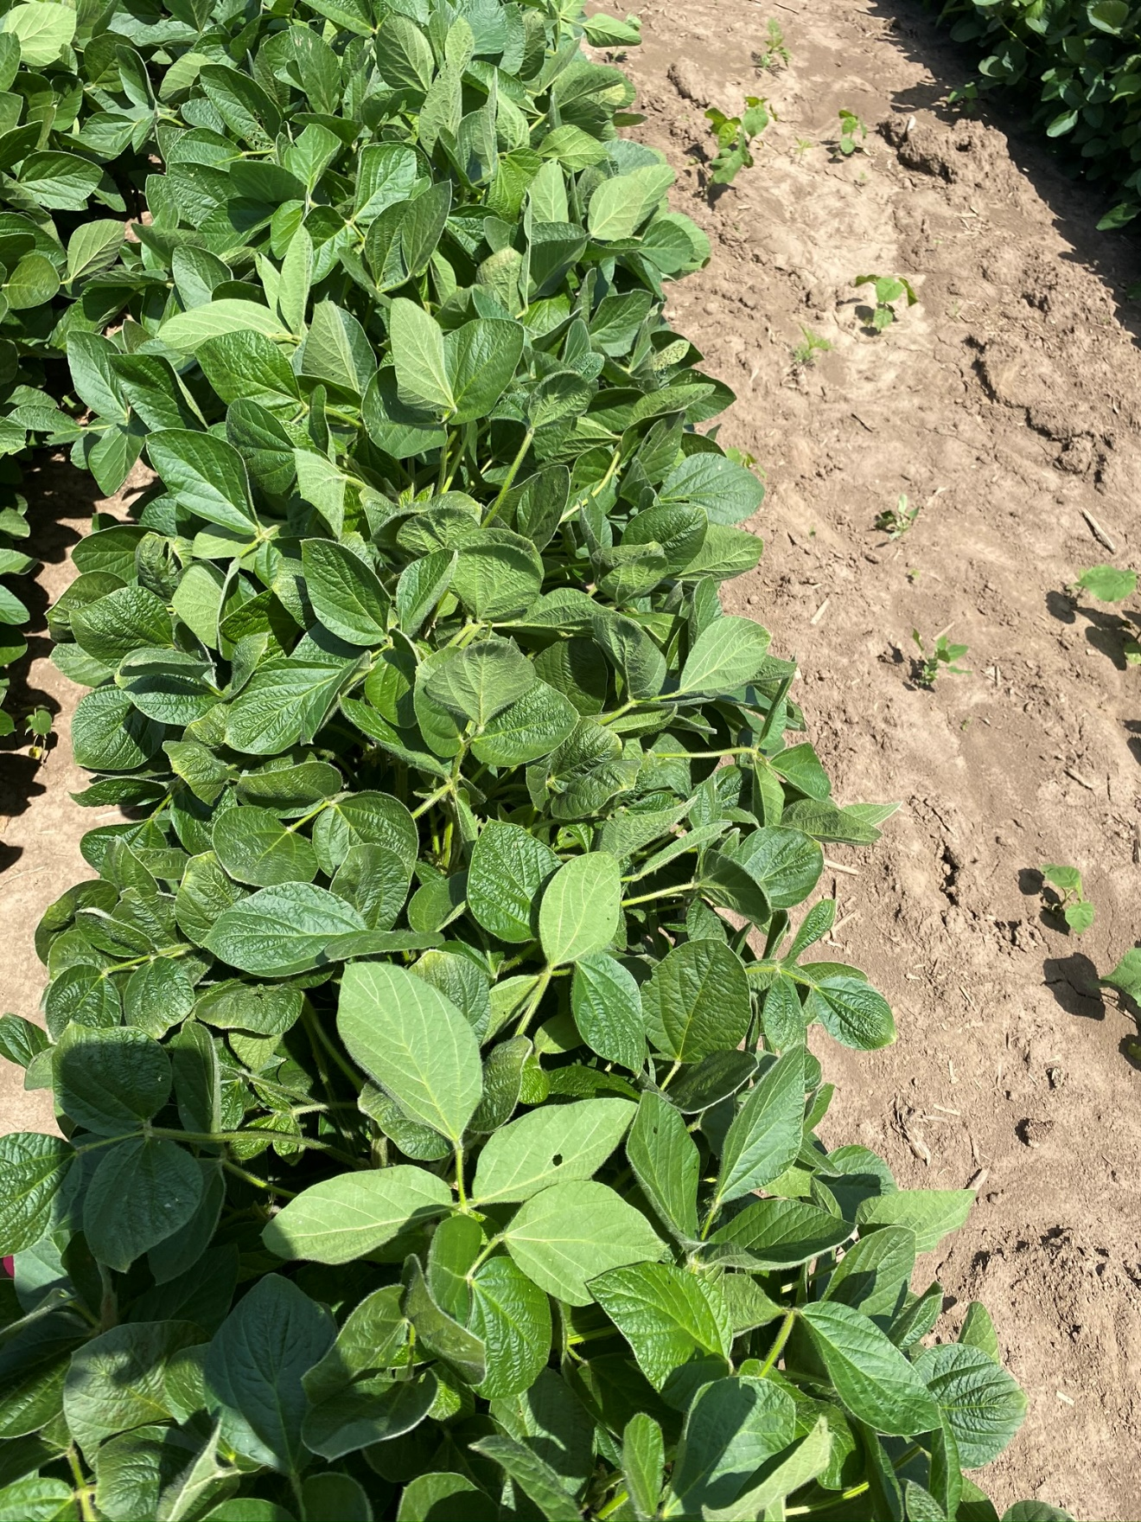

Figure 3. XtendiMax with VaporGrip + Roundup PowerMax + 4% MON 51817 –

VaporGrip at 28 DAT.

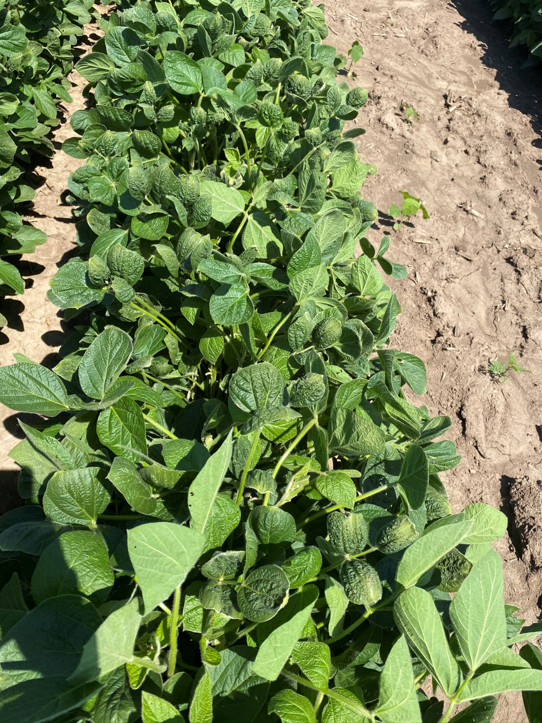

Figure 4. XtendiMax with VaporGrip + Roundup PowerMax + Liberty 280 SL at

28 DAT.

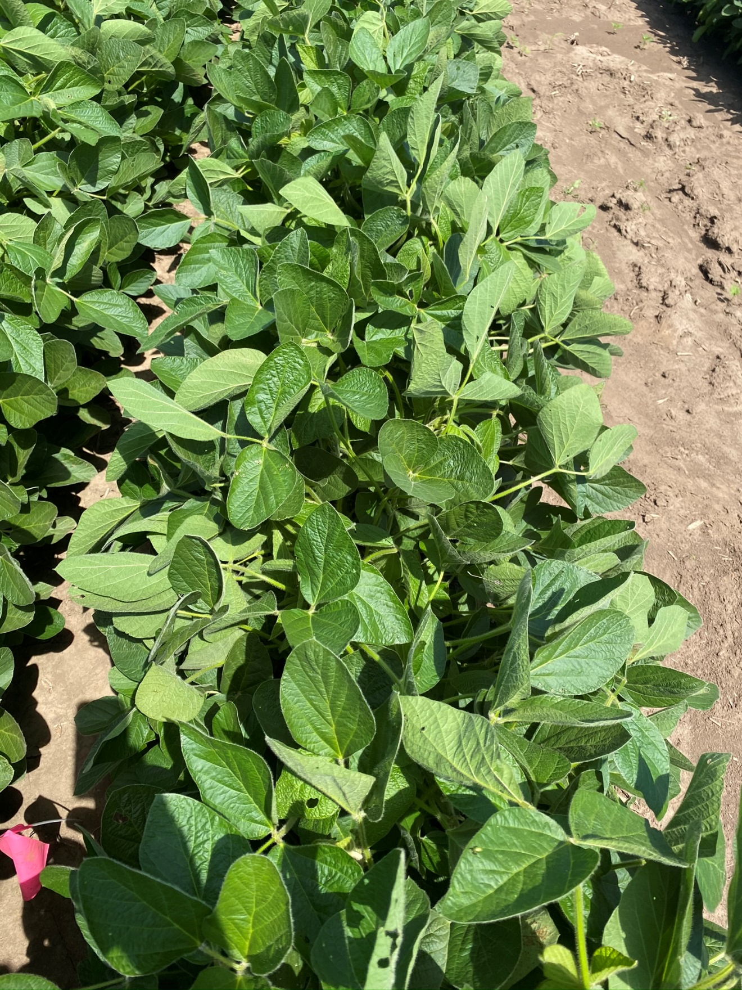

Figure 5. XtendiMax with VaporGrip + Roundup PowerMax + Liberty 280 SL + 2%

MON 51817 – VaporGrip at 28 DAT.

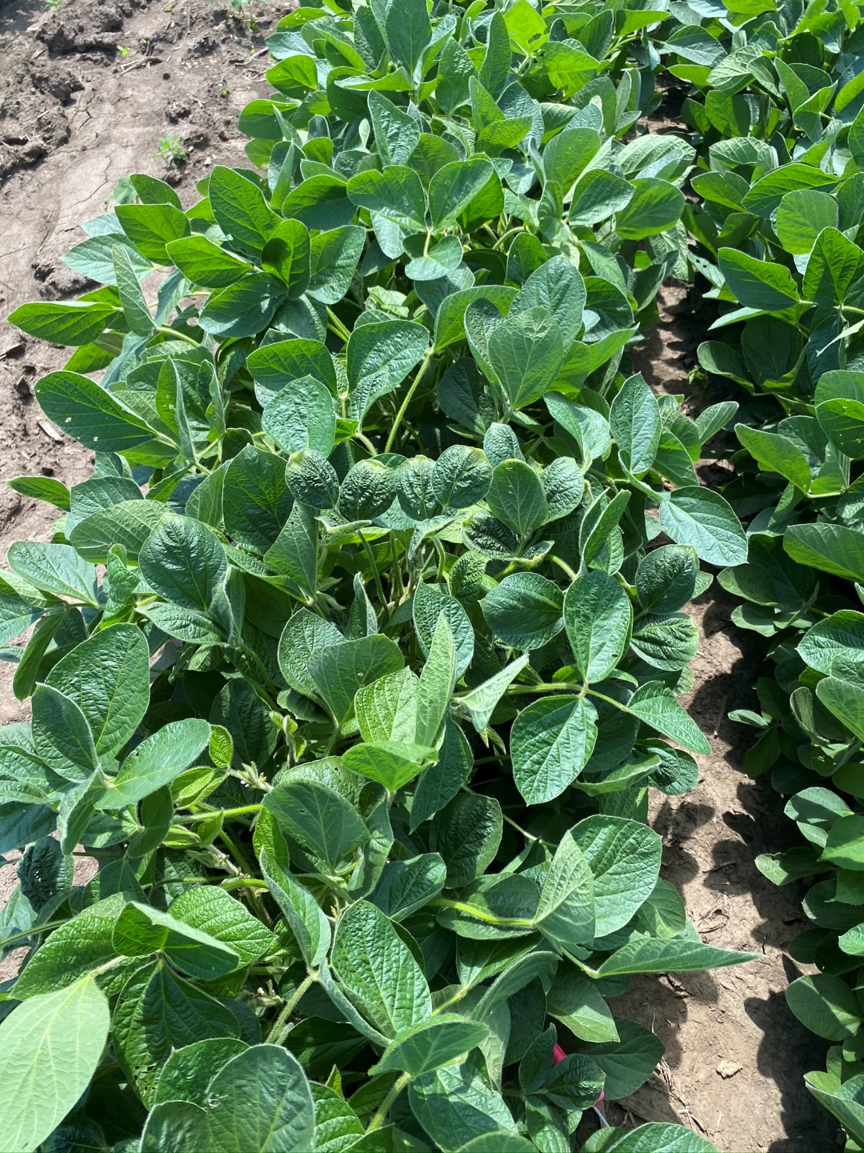

Figure 6. XtendiMax with VaporGrip + Roundup PowerMax + Liberty 280 SL + 4%

MON 51817 – VaporGrip at 28 DAT.

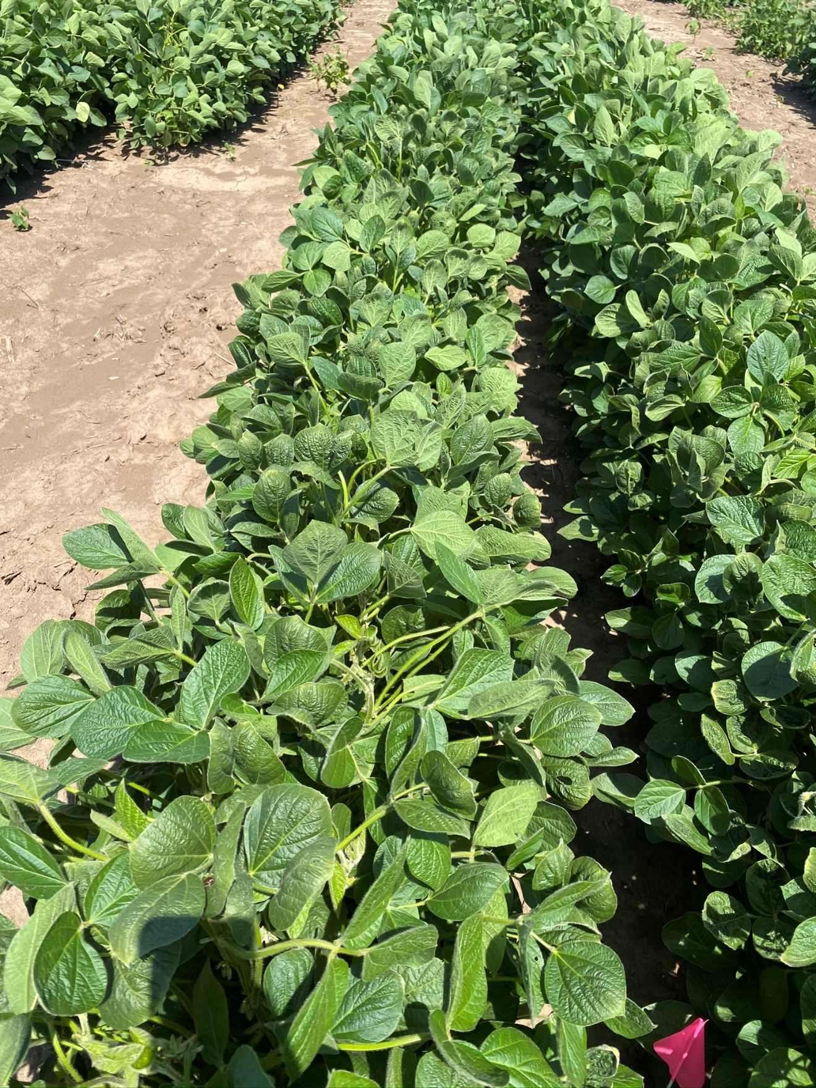

Figure 7. MON 301286 – RupXtend II VGrip at 28 DAT.

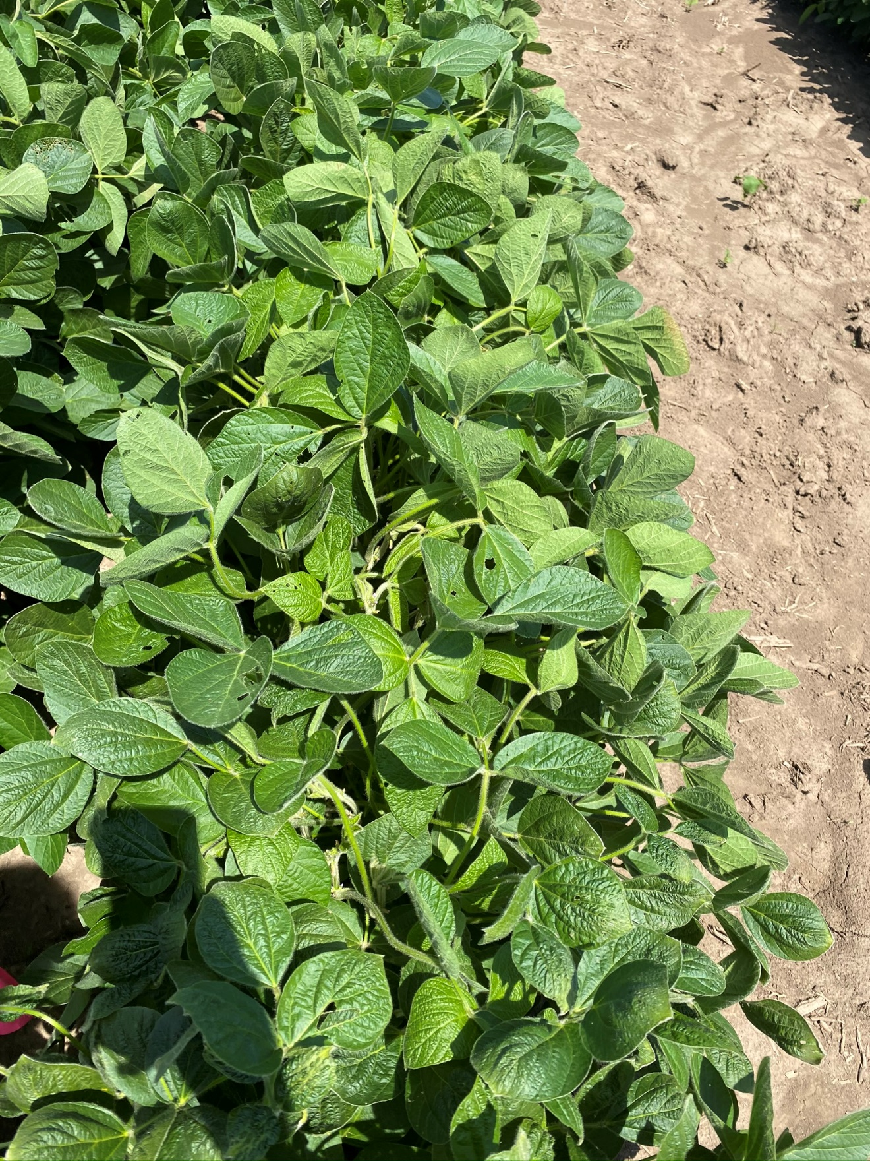

Figure 8. MON 301286 – RupXtend II VGrip + 2% MON 51817 - VaporGrip at 28

DAT.

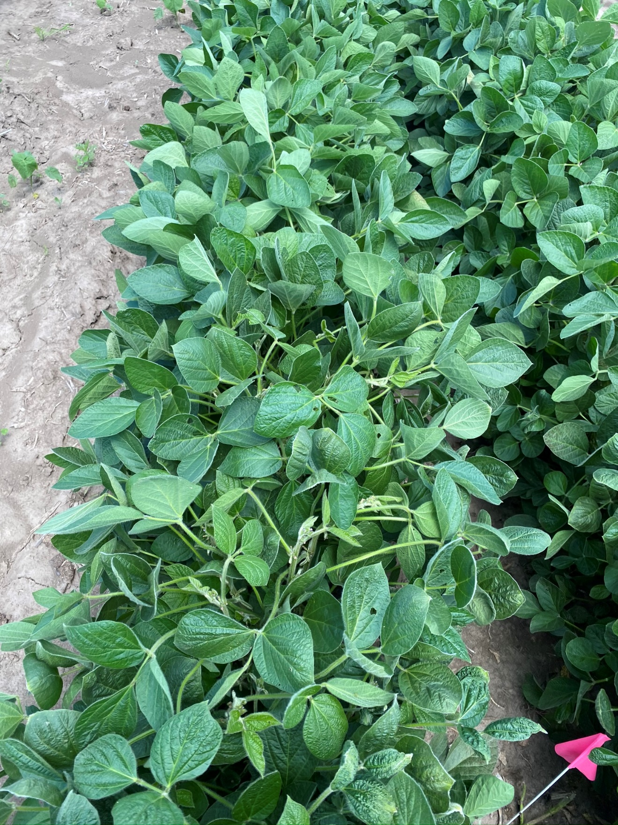

Figure 9. MON 301286 – RupXtend II VGrip + 4% MON 51817 – VaporGrip at 28

DAT.

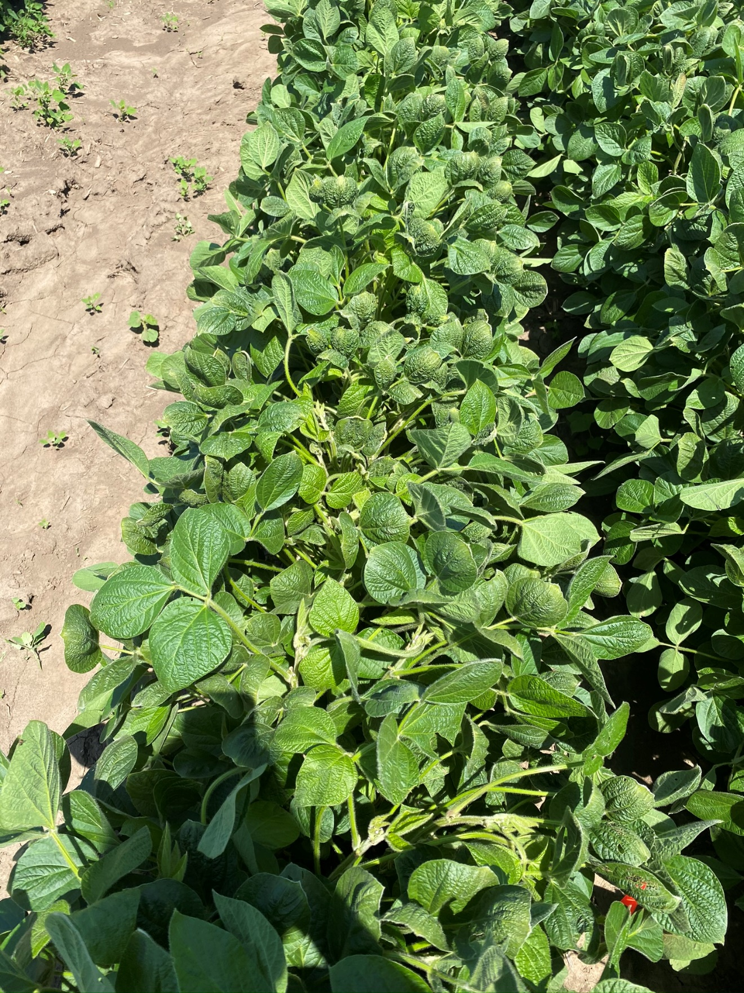

Figure 10. MON 301286 – RupXtend II VGrip + Liberty 280 SL at 28 DAT.

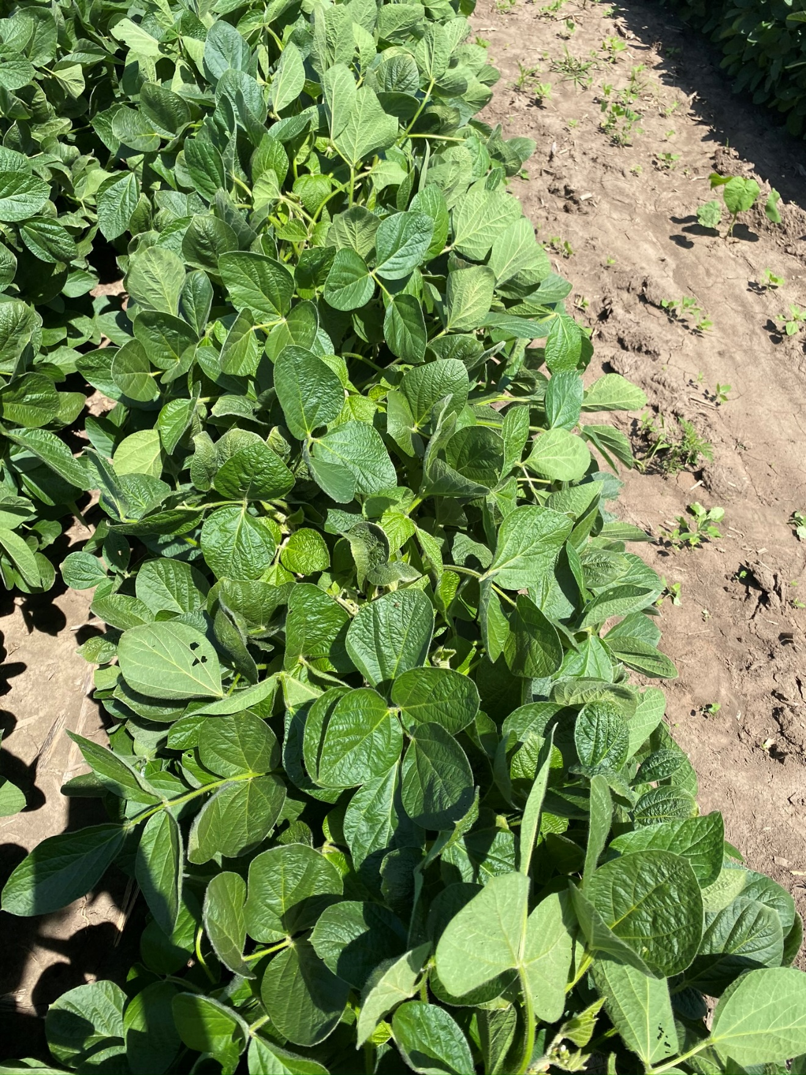

Figure 11. MON 301286 – RupXtend II VGrip + Liberty 280 SL + 2% MON 51817

– VaporGrip at 28 DAT.

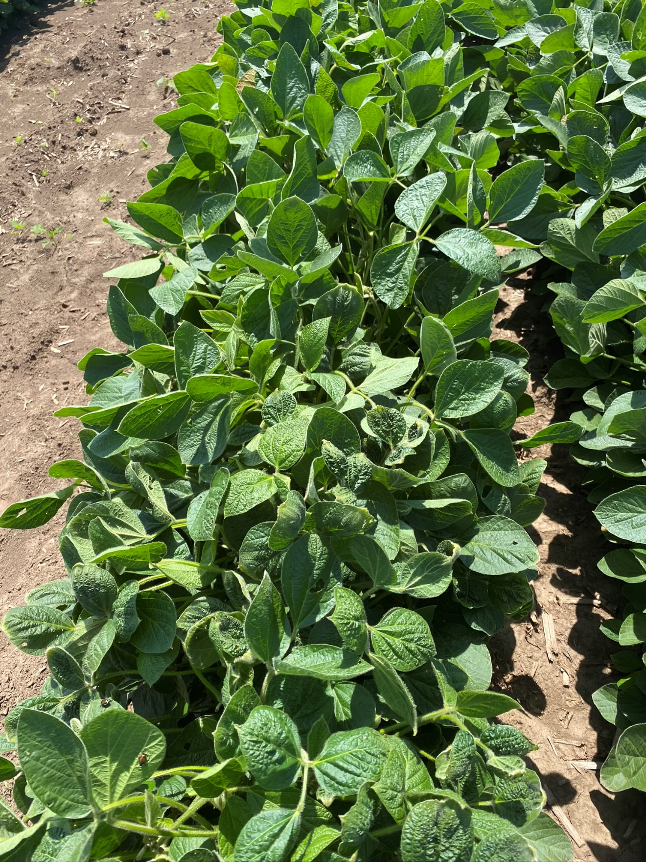

Figure 12. MON 301286 – RupXtend II VGrip + Liberty 280 SL + 4% MON 51817

– VaporGrip at 28 DAT.

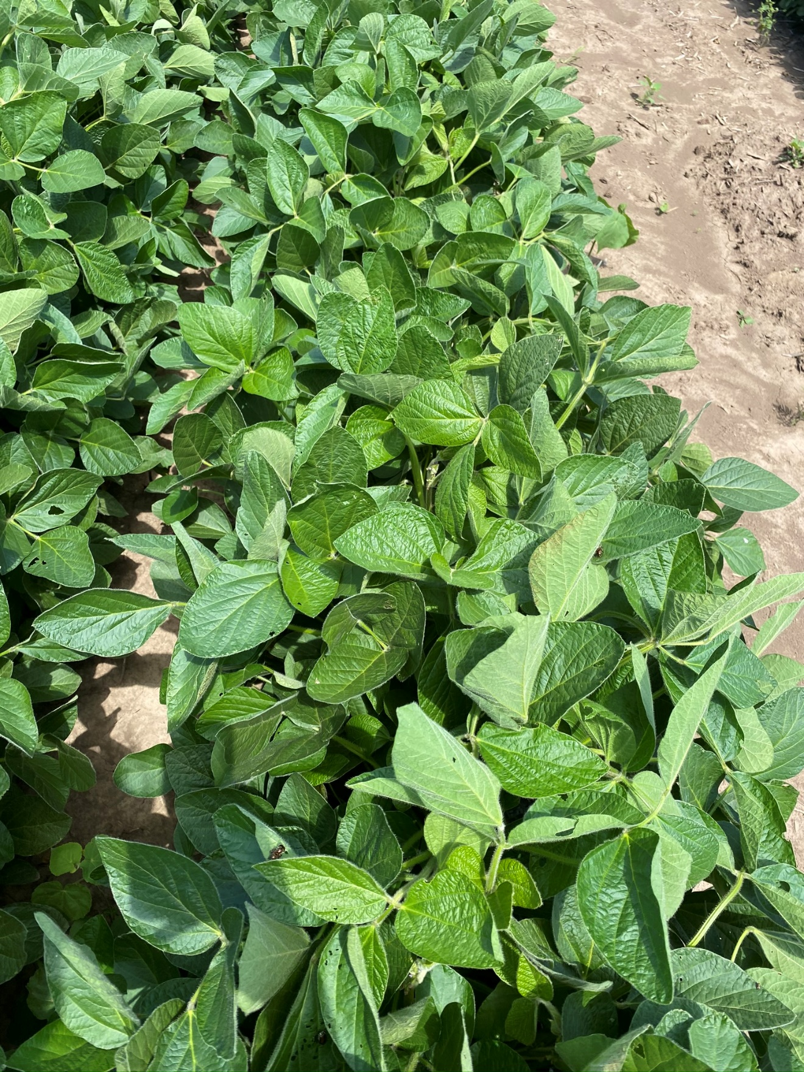

Figure 13. Nontreated Check at 28 DAT.